**HTML - CSS Questions**

**Q.1 What is doctype? Is it an element or tag?**

**Ans**.

* All HTML documents must start with a <!DOCTYPE> declaration.
* The declaration is not an HTML tag. It is an "information" to the browser about what document type to expect.
* In HTML 5, the declaration is simple: <!DOCTYPE html>
* The <!DOCTYPE> declaration is NOT case sensitive.
  + - <!DOCTYPE html>, <!DocType html>, <!doctype html>
* In older documents (HTML 4 or XHTML), the declaration is more complicated because the declaration must refer to a DTD (Document Type Definition).
* HTML 4.01:
* <!DOCTYPE HTML PUBLIC "-//W3C//DTD HTML 4.01 Transitional//EN" "http://www.w3.org/TR/html4/loose.dtd">
* Browsers also use the DOCTYPE to determine how to render a page. Not including a DOCTYPE or including an incorrect DOCTYPE can trigger quirks mode.
* The kicker here is that quirks mode in Internet Explorer is quite different from quirks mode in Firefox (and other browsers), meaning that you'll have a much harder job trying to ensure your page works consistently in all browsers if pages are rendered in quirks mode than you will if they are rendered in standards mode.
* The DOCTYPE tells the consuming user agent (web browsers, web crawlers, validation tools) what type of document the file is. Using it ensures that the consumer correctly parses the HTML as you intended it.
* There are several different DOCTYPES for HTML, XHTML, and Framesets and each of these has two modes Strict(standard) Mode and Quirks Mode. Strict says that your markup is using the defined standards exactly. See [W3C DTDs](http://www.w3.org/QA/2002/04/valid-dtd-list.html) page for further details.
* Quirks mode is basically the layout method from the browser wars days when the standards were much less respected and defined. Generally, a standards mode page, that is valid, will layout more consistently across various browsers, but may lack certain features that you require. One such features is the anchor tag's target attribute. The [Quirksmode](http://www.quirksmode.org/css/quirksmode.html) site is a great resource for these differences.
* Using this DOCTYPE is a forward compatible way to specify that your pages are in standards mode and are HTML. This is the method that Google uses and is reasonably easy to remember. I recommend using this DOCTYPE unless you plan to use XHTML.
* Ex: IE9 in quirks mode does not identify ‘canvas’ tag. HTML api’s may not work.

**Q.2 What happens if I won't write doctype?**

**Ans**. The browser enters [Quirks](https://en.wikipedia.org/wiki/Quirks_mode)mode and tries to deal with your code as if it was written in the late 90’s. This means they will imitate many bugs that existed in the old browsers. It is not consistent on how to do this (so you will get significantly different results, for example, from Firefox to Internet Explorer).

The purpose of DOCTYPE is to tell the browser what type of HTML you are writing. It is not valid to omit the DOCTYPE. There is no “Standard” format. The browser will just try to parse HTML as best it can. But not all elements will be displayed correctly. DOCTYPE is a required part of all HTML documents.

**Q.3 If won't write doctype, will HTML5 API will work or not?**

**Ans**. It depends on the target browsers. Webkit-browsers, Firefox and Opera will handle HTML5 elements quite normally even if your doctype is not HTML5.

IE9 on the other hand (I bet you saw this coming), may behave entirely differently on another type of doctype. If IE9 is not in IE9 Standards mode (it could be in quirks, IE8 compact, whatever), it will *not* support the HTML5 features it does in IE9 standards.

So essentially your main concern is that you need to make sure all browsers go into strict standards mode. The easiest way to achieve this is to use the HTML5 doctype, since it will trigger standards mode in all browsers - *including* older browsers that don't actually support HTML5.

**Q.4 Tell some new HTML tags?**

**Ans**. Article, audio, video, canvas, svg, footer, header, nav, section, time

New types for input tags: color, date, datetime, email, month, number, range, search, tel, time, url, week.

**Q.5 What is semantic tag? Use and example of semantic tag?**

**Ans**.

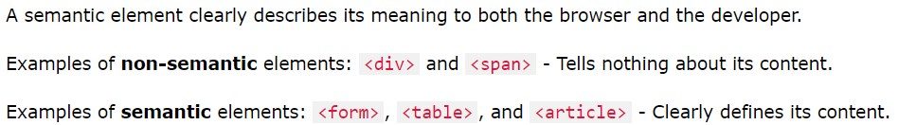

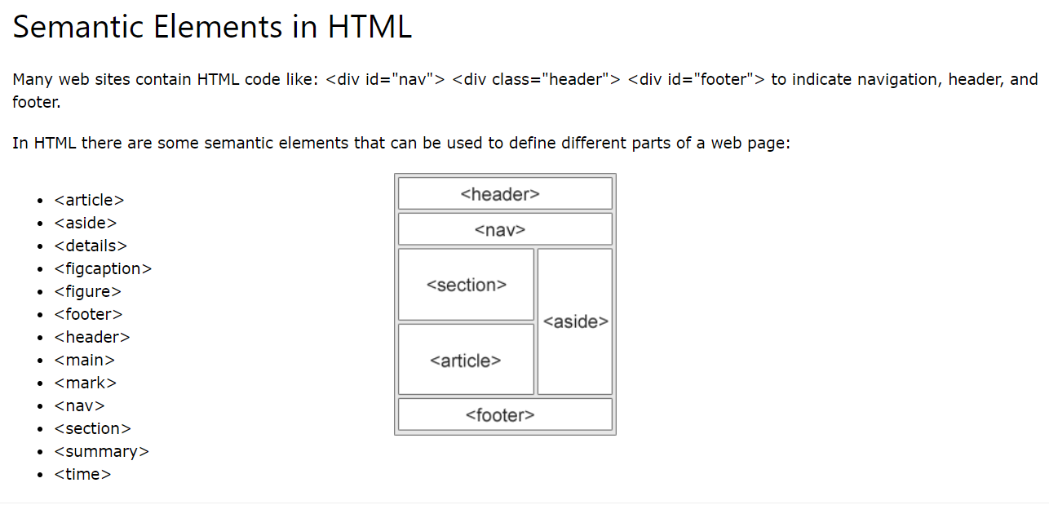

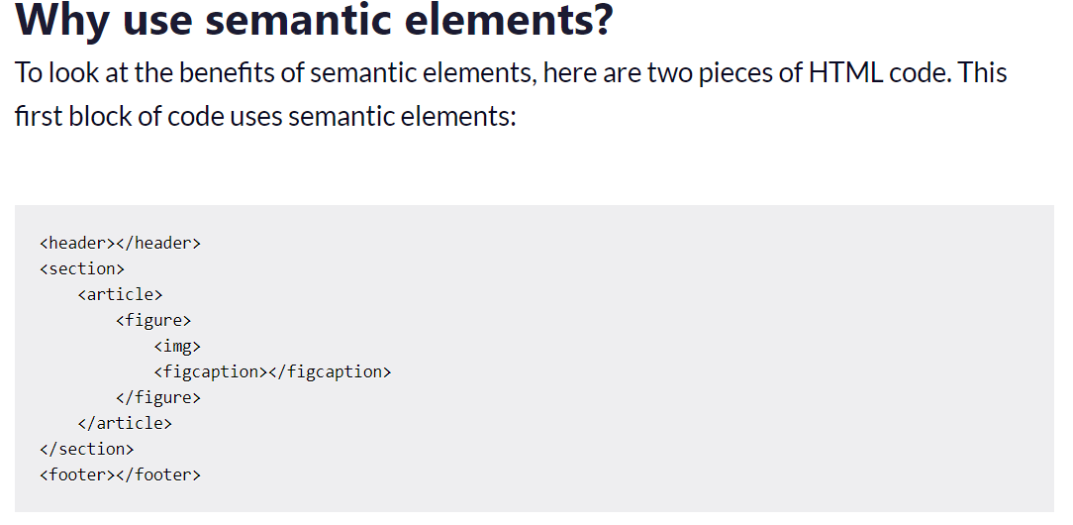

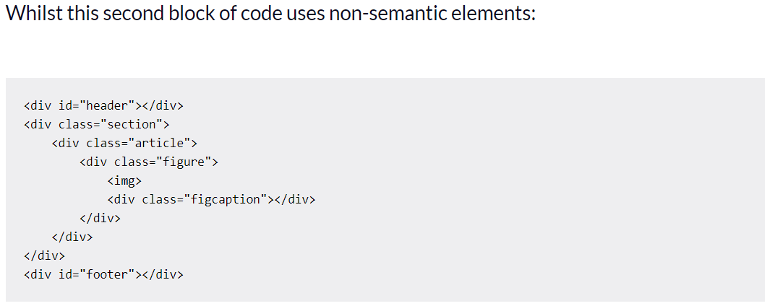

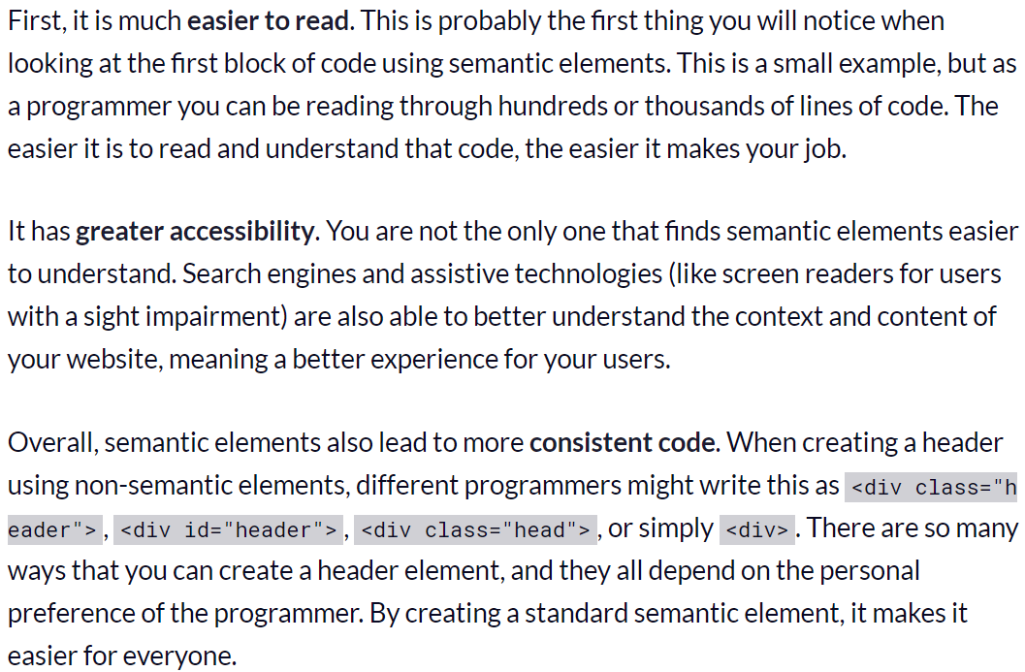

**Q.6 Before HTML5 do we have this concept of semantic tag?**

**Ans**. No. Since October 2014, HTML4 got upgraded to HTML5, along with some new “semantic” elements.

Q.7 What happens if I write Footer tag before Header tag?

Q.8 Web optimization techniques?

**Q.9 What are the HTML5 API's?**

**Ans**. <https://www.sitepoint.com/10-html5-apis-worth-looking/>

1. High Resolution Time API
2. Navigation Timing API
3. Network Information API
4. Page Visibility API
5. Media API
6. Text Trac API
7. Fetch
8. Canvas and Canvas API – 2D Graphics
9. History
10. SVG
11. Video and Audio API
12. QuerySelector and QuerySelectorAll
13. LocalStorage, SessionStorage and Indexed DB
14. FileAPI --> (window.FileReader())
15. WebSockets
16. Non-XHR, XHR and XHR-2
17. Camera API
18. ContentEditable
19. new Image()

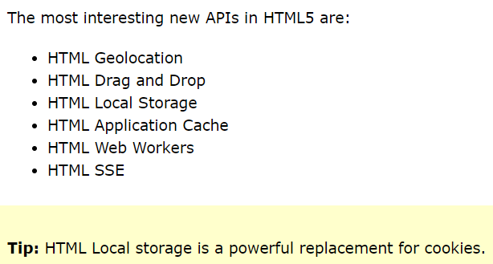

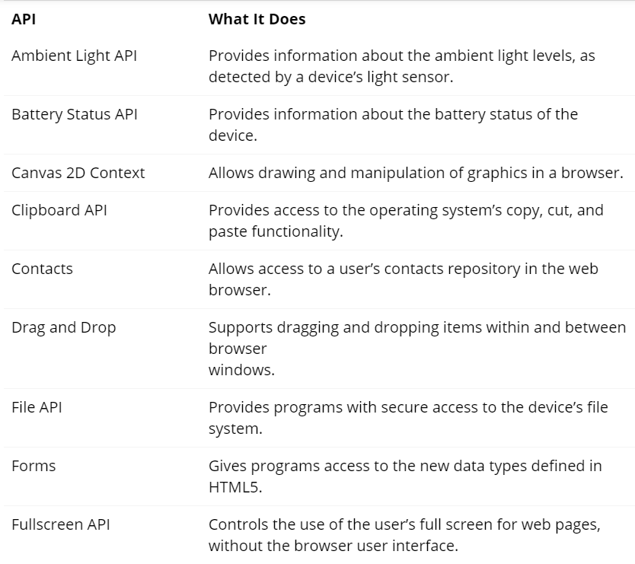

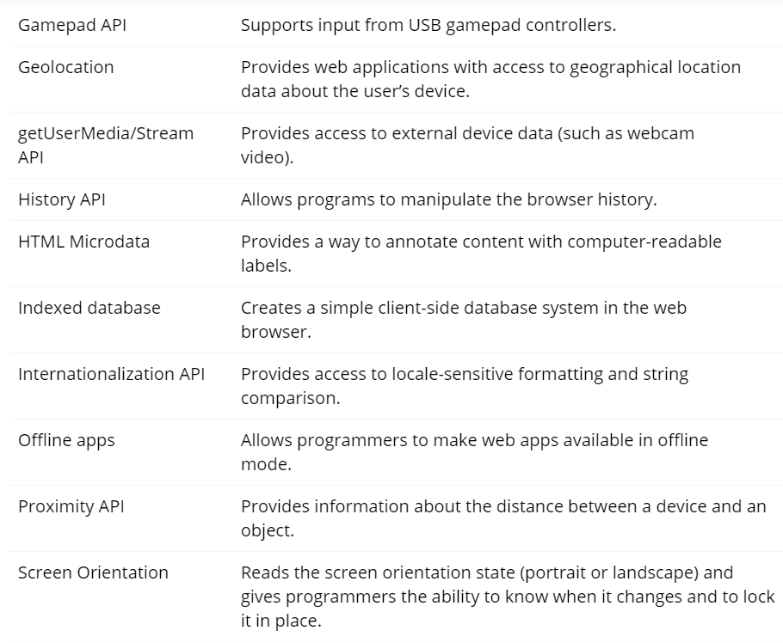

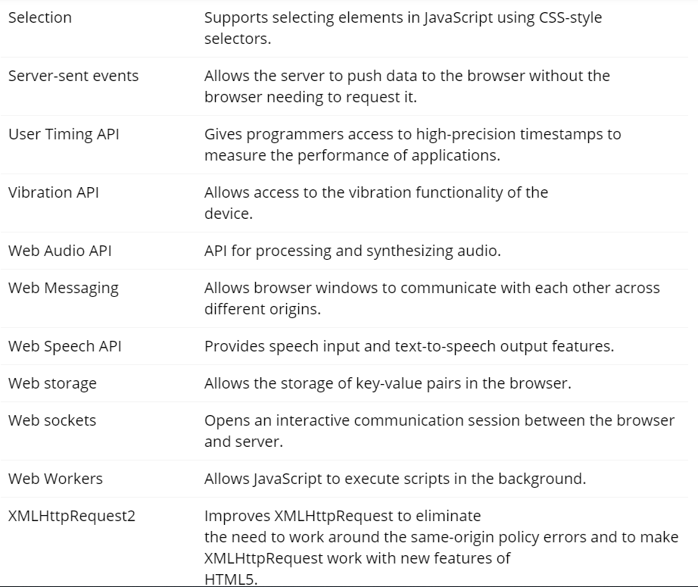

**Q.10 What is the different between local storage, session storage and cookies. and how to set, get and delete them?**

**Ans**.

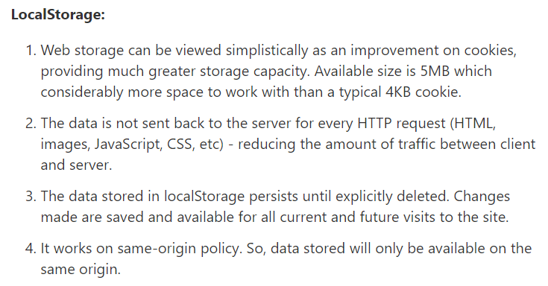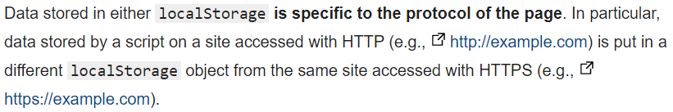

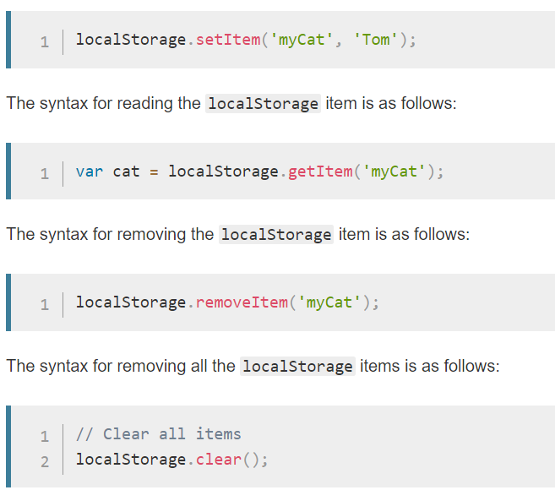

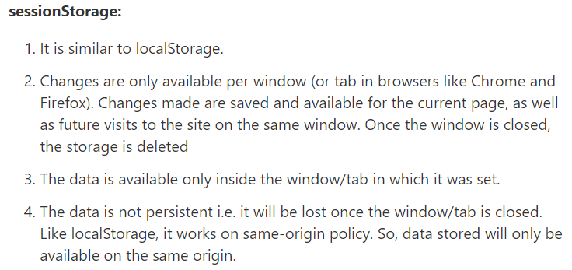

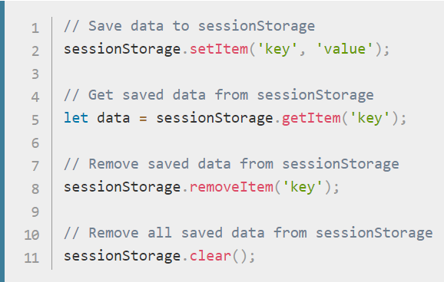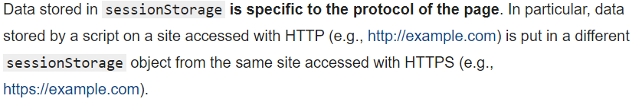

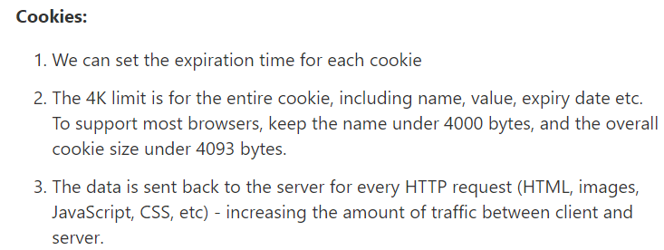

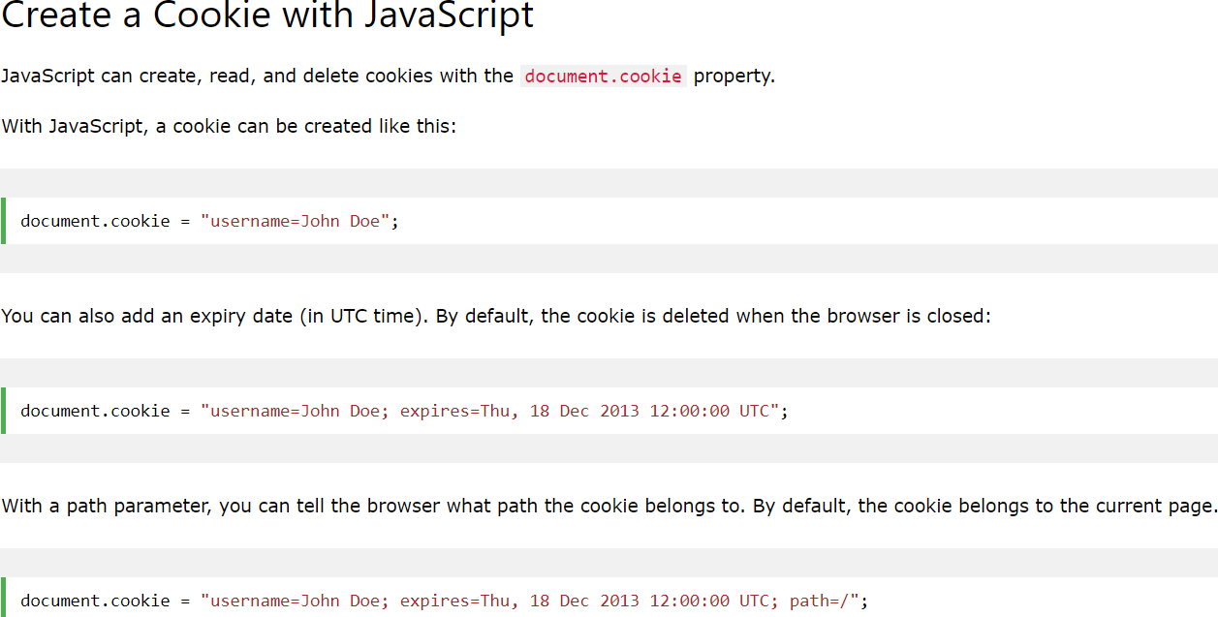

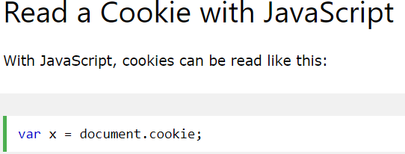

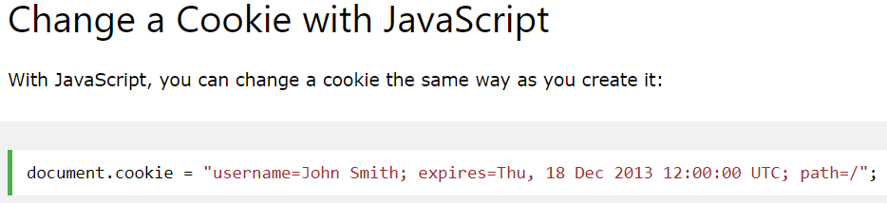

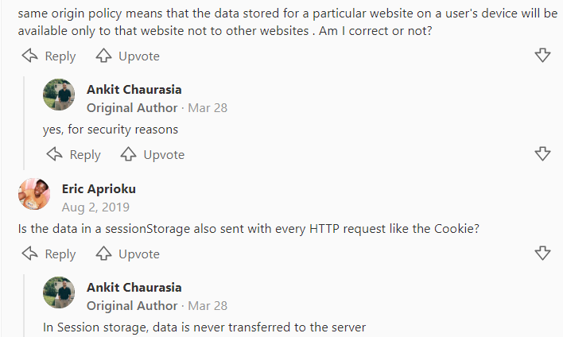

**Q.11 How values are stored in local storage, session storage, cookies.**

**Ans.** we stored in key-value pair and both keys and values should be in string

**Q.12 How to store object in local storage, session storage, cookies**

**Ans**. we have to convert object into string with JSON.stringify as everything should be in string.

**Q.13 How to create cookies?**

**Ans.** With document.coockies. Generally, we don't cookies it is set by the server.

**Q.14 Form tag submit behavior?**

**Ans**. It is a semantic tag. We should use it if we are creating forms.



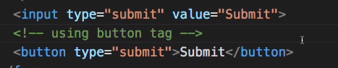

Form will be submitted on server **non-XHR way**.

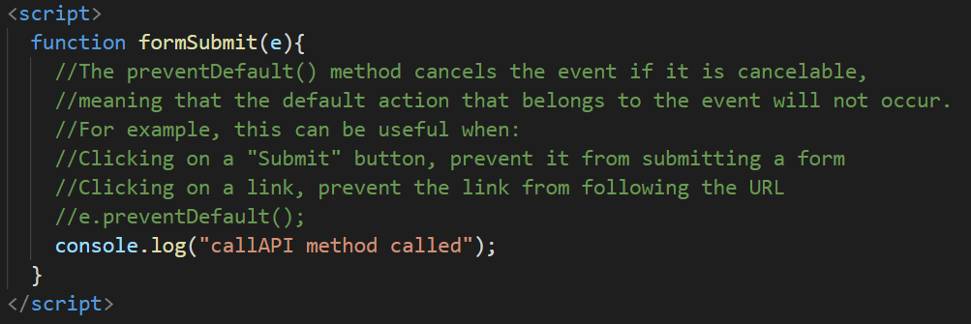

**Q.15 Event Bubbling and Event capturing?**

**Ans.**

Bubbling:

**When an event happens on an element, it first runs the handlers on it, then on its parent, then all the way up on other ancestors.**

**Capturing:**

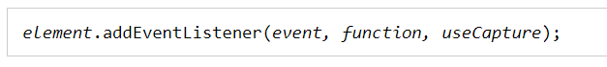

The third parameter is a Boolean value specifying whether to use event bubbling or event capturing. This parameter is optional.

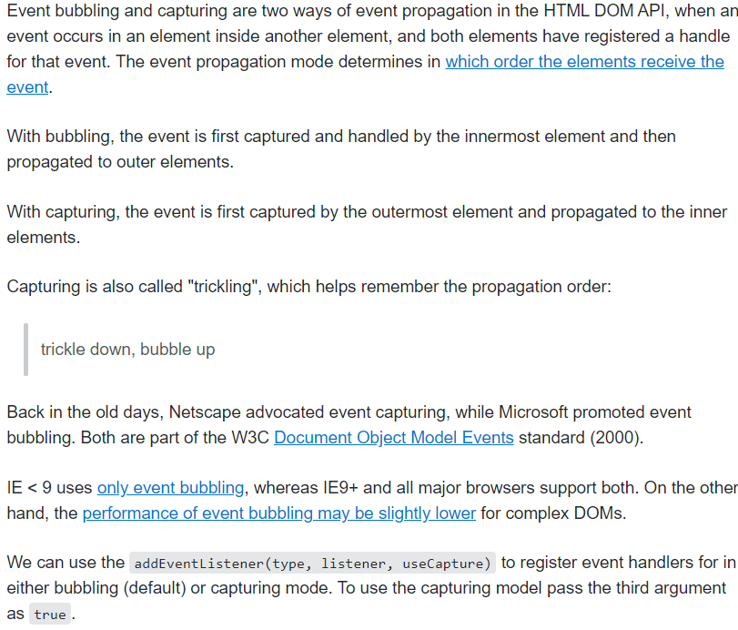

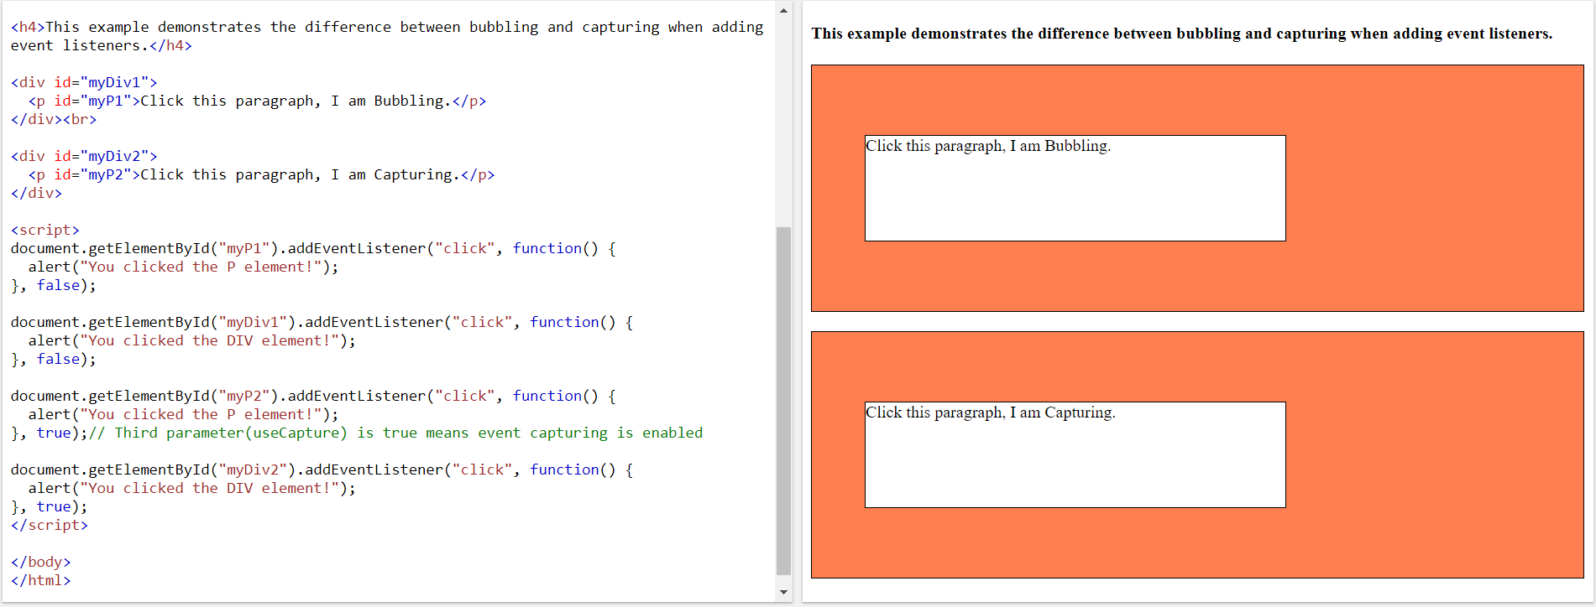

**Q.16 How to achieve event capturing?**

**Ans**. Possible only while adding addEventListner. Pass third arguments as true.

**Q.17 What are the phases of event propagation?**

**Ans.** The standard DOM Events describes 3 phases of event propagation:[Capturing, Target, Bubbling] check javascriptinfo.

**Q.18 event.preventDefault and event.stopPropagation?**

**Ans.**

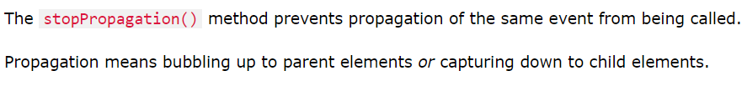

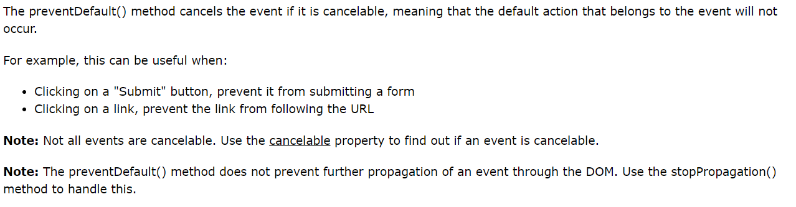

**Q.19 How to add JS and CSS in HTML file?**

**Ans.**

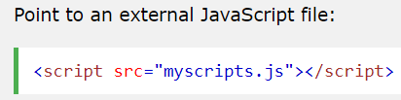

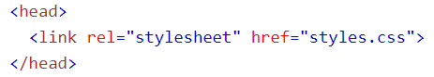

**Q.20 Add Comment in HTML file?**

**Ans**. <!-- A SAMPLE COMMENT -->

**Q.21 How do you insert a copyright symbol on a browser page?**

**Ans**. “&copy;” or & “#169;”

**Q.22 How to create a nested webpage in HTML?**

**Ans**. The HTML iframe tag is used to display a nested webpage.

**Q.22 How to stop Event Bubbling and Event capturing?**

**Ans.** 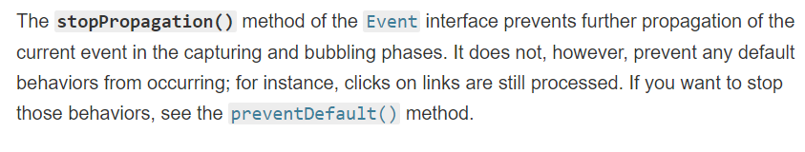

Q.23 In which format Local/Session storage data stores.

Ans. key-value pairs, both should be string

Q.24 Can we give width to span?

Ans. No it is inline element and for inline elements we can't set width

Q.25 List some block level and inline element?

Ans.

Block: A block-level element always starts on a new line and takes up the full width available (stretches out to the left and right as far as it can).

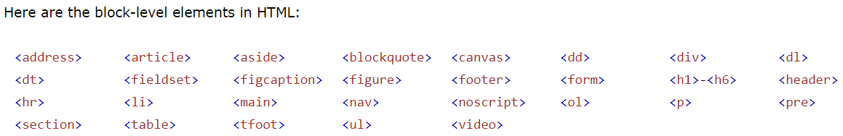

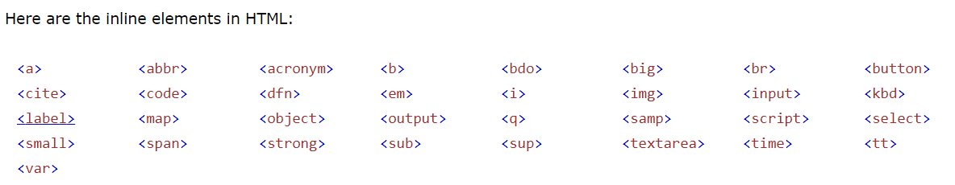

Q.26 What is SVG? Difference between canvas and SVG?

Ans.

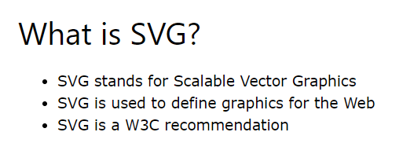

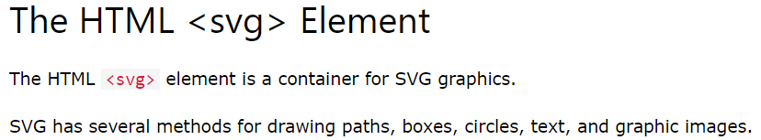

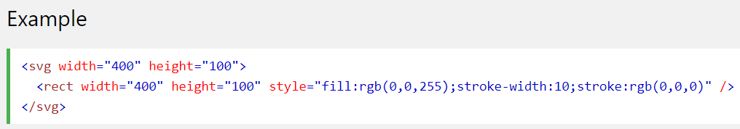

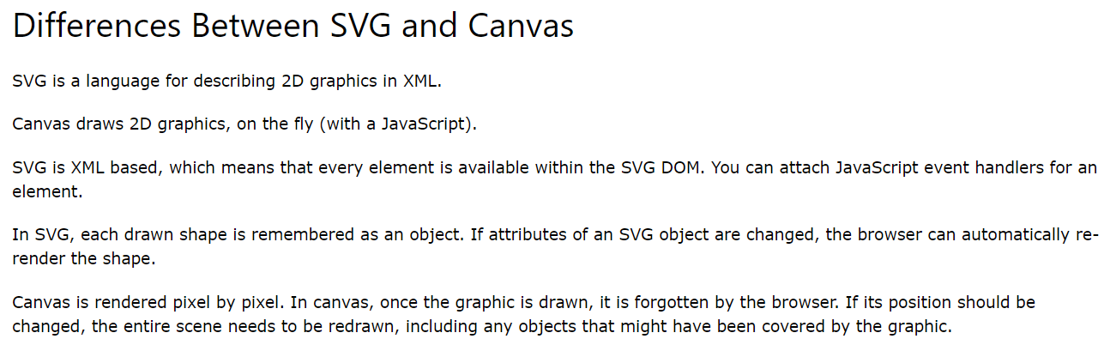

Comparison:

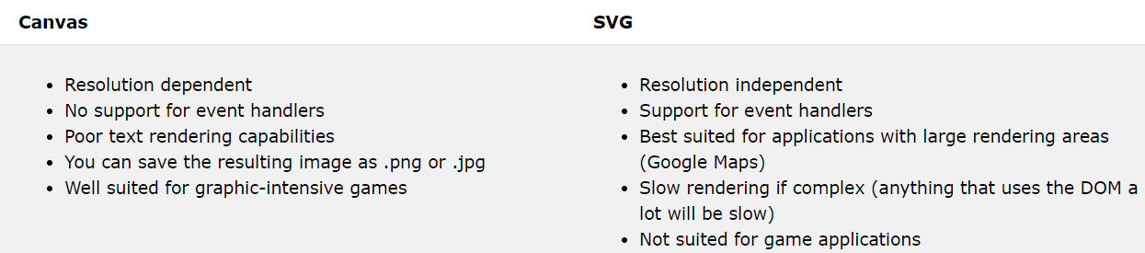

Q.27 Where does browser stores local and session storage?

Ans. Chrome stores in separate files inside the Local Storage directory.

<https://stackoverflow.com/questions/8634058/where-the-sessionstorage-and-localstorage-stored>

%LocalAppData%\Google\Chrome\User Data\Default\Local Storage\

Q.28 How to find geo location of browser?

Ans. 

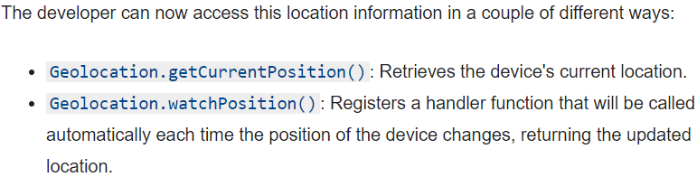

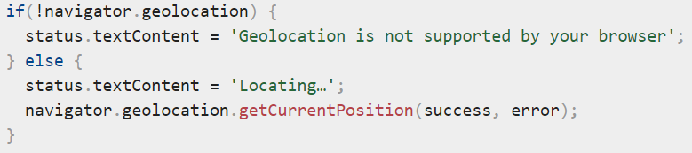

Q.29 Web storage in HTML5?

Ans. HTML web storage; better than cookies.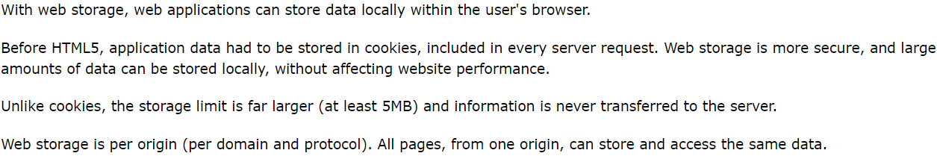

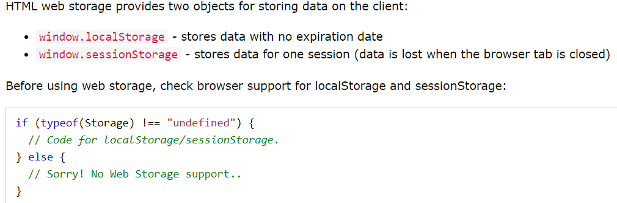

Q.30 What is Web workers?

Ans. I have an example of worker thread in HTML5 training.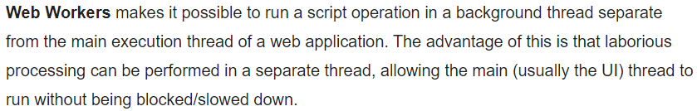



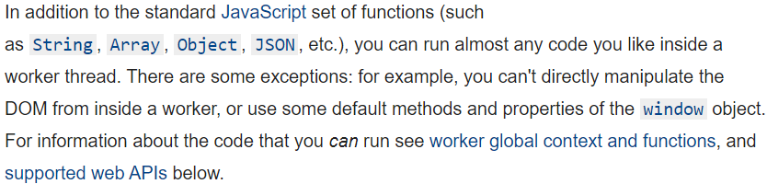

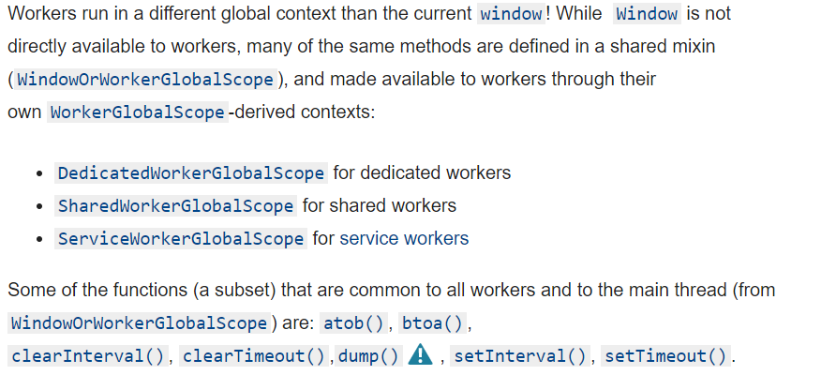

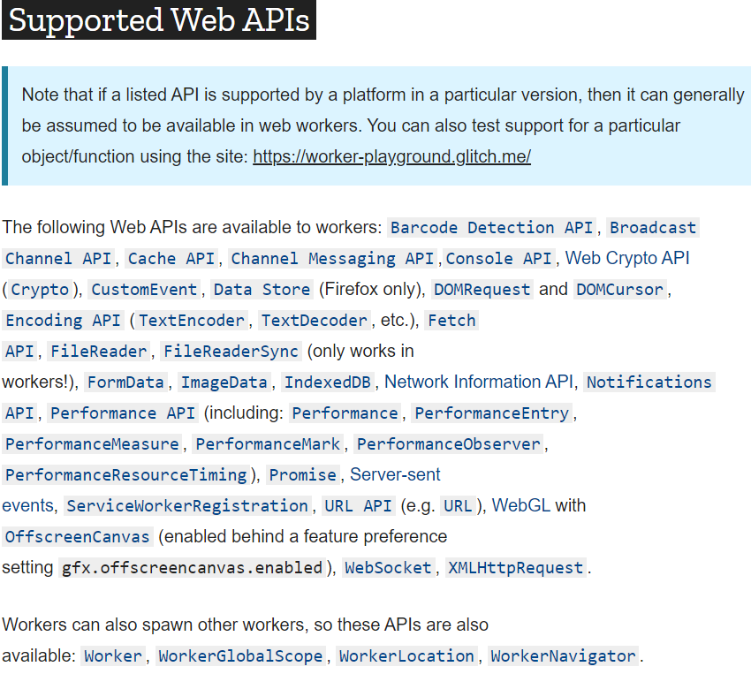

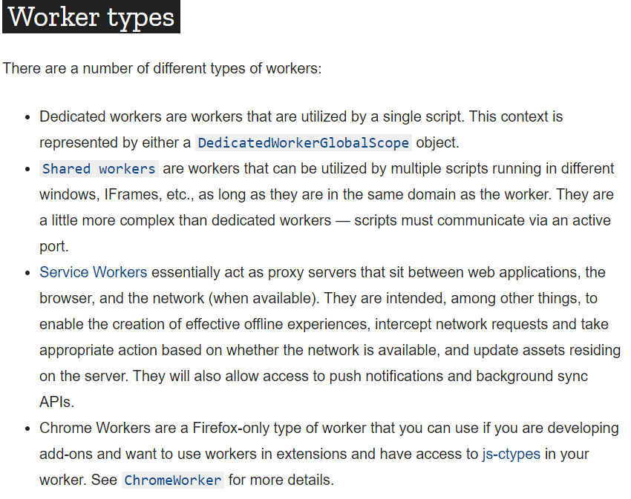

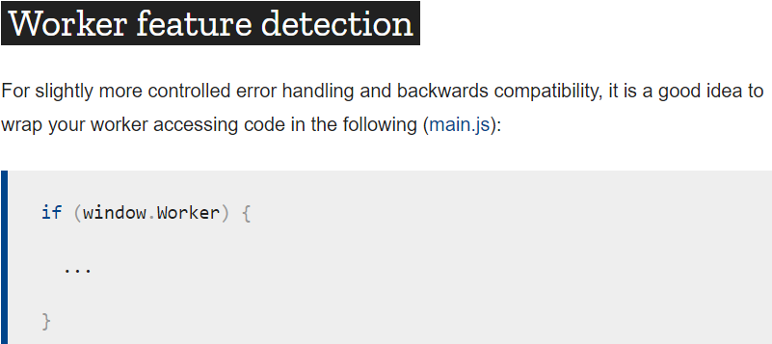

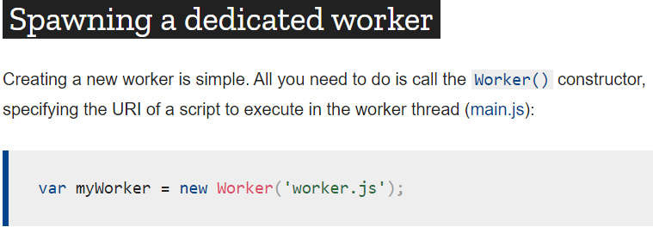

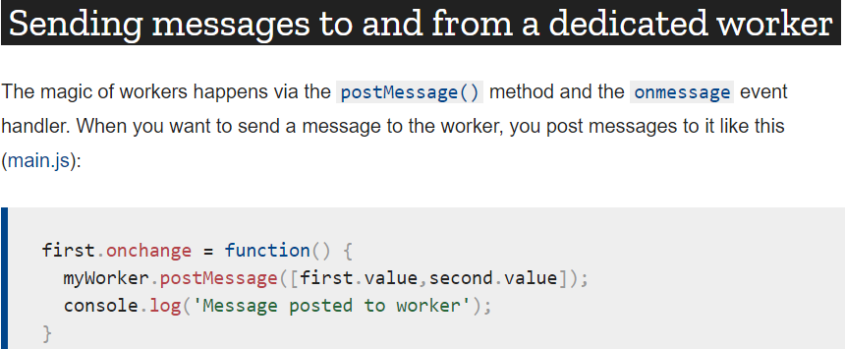

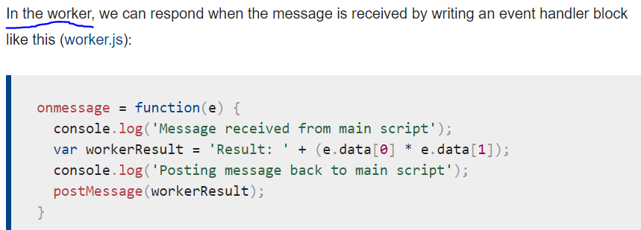

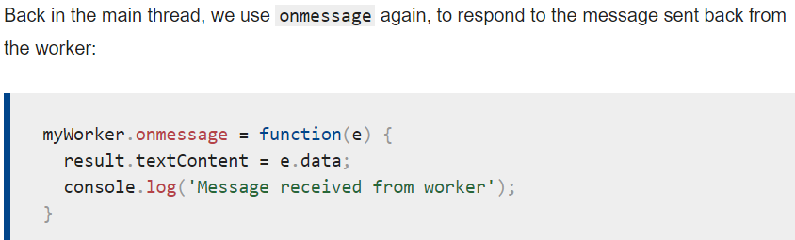

Q.31 What are the diff tags introduces in HTML5?

Ans. Article, aside, footer, header, dialog, main, nav, progress, section, summary, time

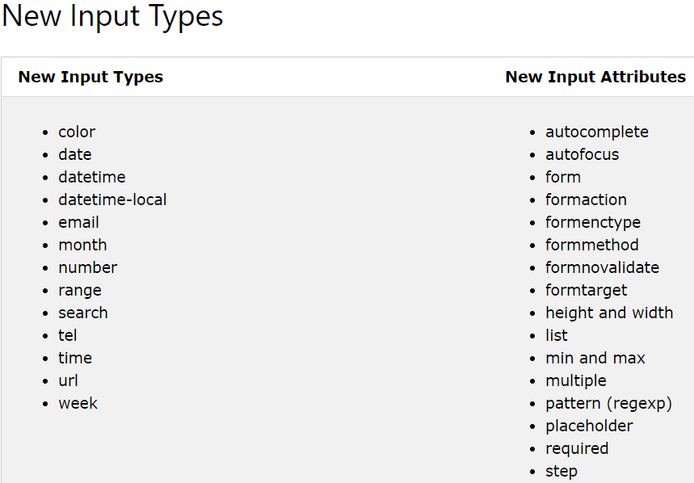

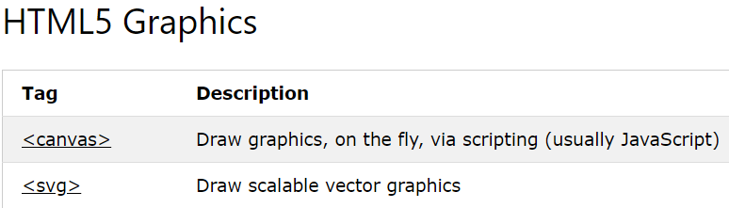

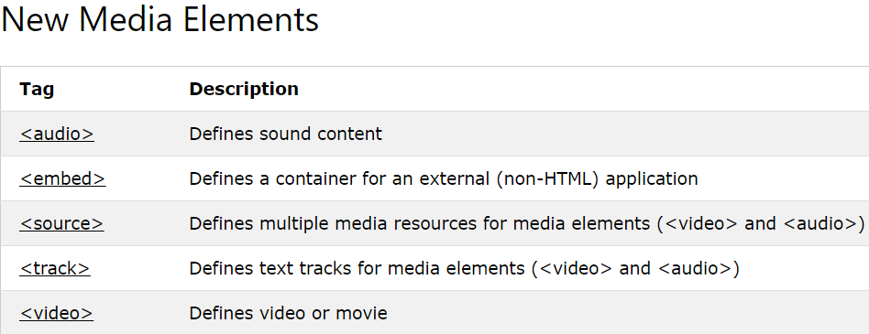

Q.32 Can we have multiple header tags and what is the use of header tags?

Ans. We can use anywhere for header section, for headline of any other section, article or page.

Q.33 css2 vs css3?

Ans.

Q.34 What is BOM?

Ans. The Browser Object Model (BOM) allows JavaScript to "talk to" the browser.

There are no official standards for the **B**rowser **O**bject **M**odel (BOM).

Since modern browsers have implemented (almost) the same methods and properties for JavaScript interactivity, it is often referred to, as methods and properties of the BOM.

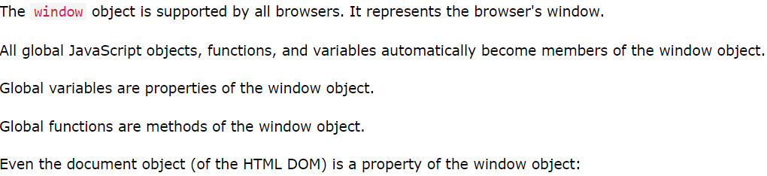

Q.35 Difference between attribute and property?

Ans.

Q.36 Can footer have header tag?

Ans. 